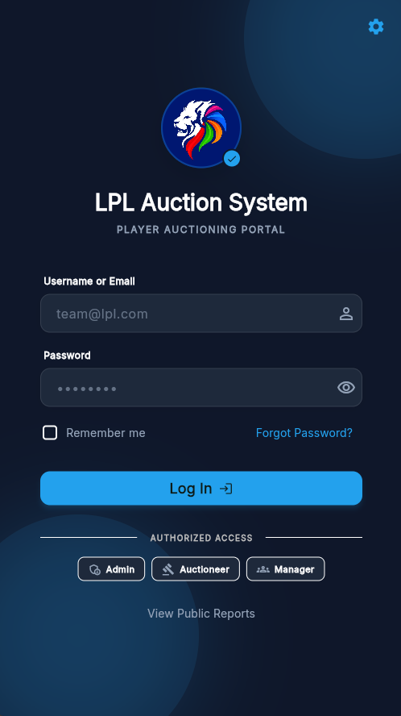
AUCTIONING SYSTEM FOR LPL

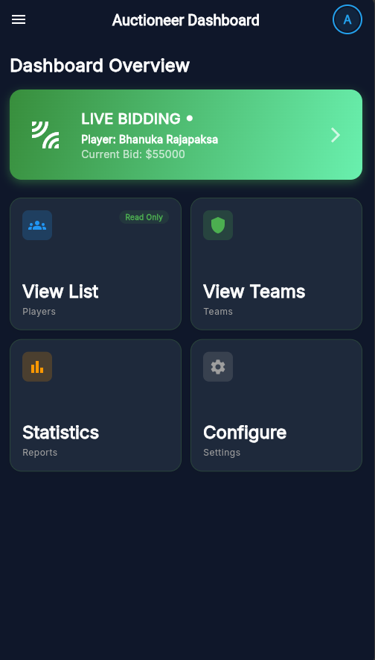

1. Introduction
By
Fazrul Rahuman Mohammed Zaharan (CL/HDCSE/CMU/123/92)
Mohamed Shums Mohamed Shazni (CL/HDCSE/CMU/123/42)
Podithuwakku Arachchige Mishad Avishka Anthony (CL/HDCSE/CMU/123/48)
Panneer Selvam Anushan (CL/HDCSE/CMU/123/124)

User Manual
FEB 2024
This user manual provides step-by-step guidance on how to use the Cricket Players Auctioning System for the Lanka Premier League (LPL). The system is designed to automate the player auction process by enabling secure authentication, real-time bidding, budget management, and auction control through a mobile-based application supported by a backend server.
This manual is intended for:
- System Administrators
- Auctioneers
- Franchise Team Managers
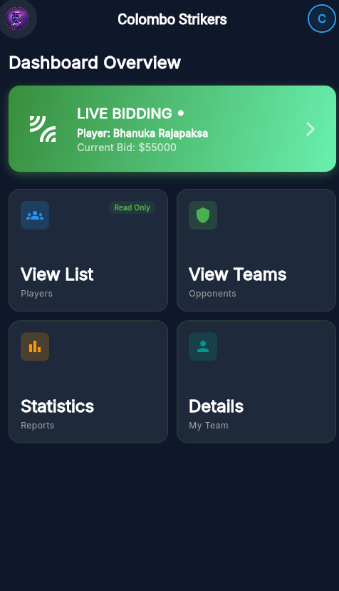
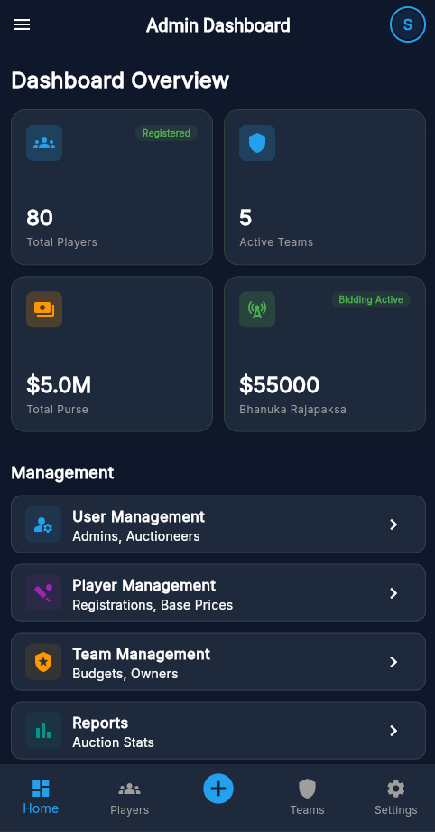
2. System Requirements
Hardware Requirements
- Android mobile device or Android emulator
- Minimum 16GB RAM recommended for development/testing machines
Software Requirements
- Android OS (latest stable version recommended)

- Flutter mobile application
- Backend server running on Node.js
- MySQL database server
- Internet connection for real-time bidding
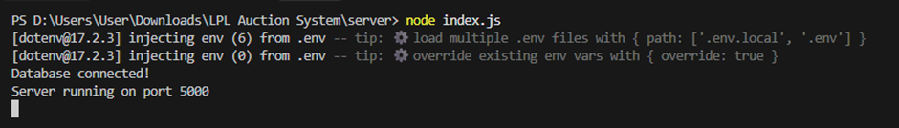
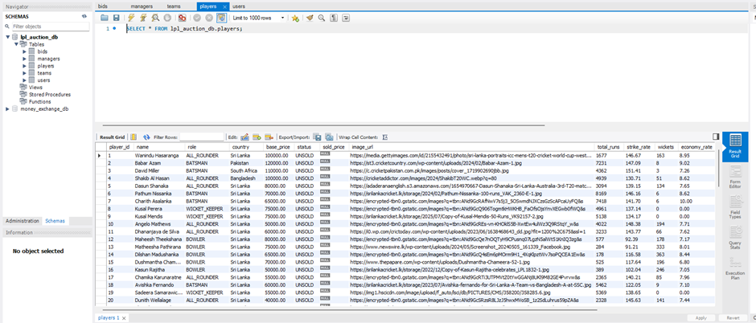
3. User Roles and Permissions
Role | Description
Administrator | Manages users, players, and system configuration
Auctioneer | Controls auction flow and bidding rounds
Team Manager | Participates in bidding and manages team budget
Each user is granted access only to features relevant to their role.
4. System Access and Login
4.1 Launching the Application
- Open the Cricket Players Auctioning System mobile application.
- Ensure the backend server is running and connected.
4.2 User Login
- Enter registered email address.
- Enter password.
- Tap the Login button.
- Upon successful authentication, the user is redirected to the relevant dashboard.
Error Handling:
- Invalid credentials will display an error message.
- Unauthorized users cannot access the system.

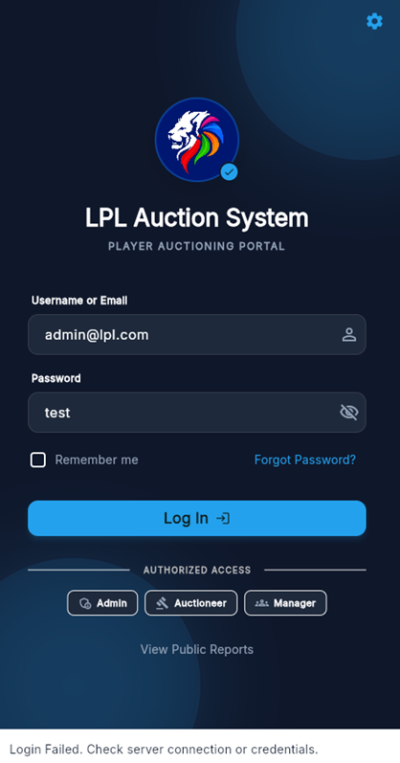
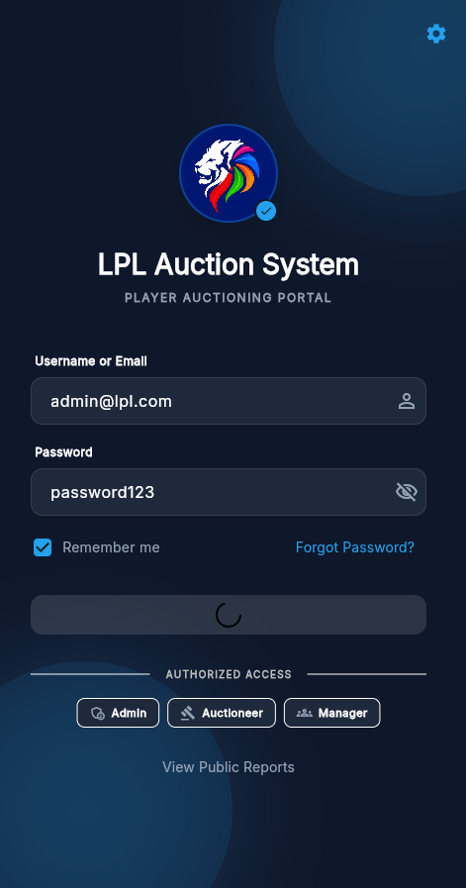
5. Administrator Functions
5.1 Player Management
- Log in as Administrator.
- Navigate to Player Management.
- Click Add Player.
- Enter:
  - Player name
  - Player role
  - Base price
- Save the player details.
The added player will be stored in the database and made available for auction.
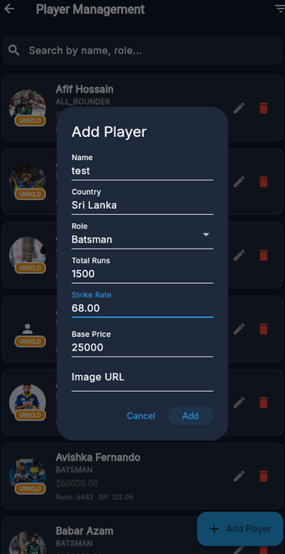
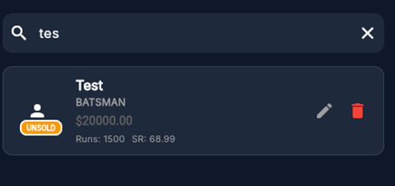
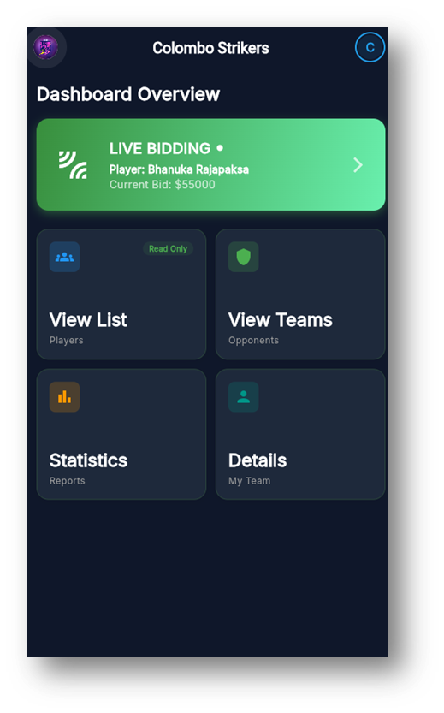
6. Team Manager Functions
6.1 Viewing Team Dashboard
- Log in as Team Manager.
- The dashboard displays:
  - Total team budget
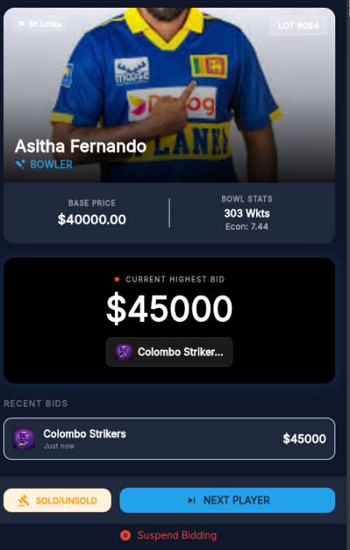
  - Remaining budget
  - Purchased players
6.2 Placing a Bid
- Navigate to the Live Auction screen.
- Enter bid amount.
- Click Place Bid.
- If valid:
  - Bid is accepted
  - Highest bid updates in real time
- If invalid:
  - System displays an error message
Note:
Bids exceeding remaining budget or lower than the current highest bid are automatically rejected.
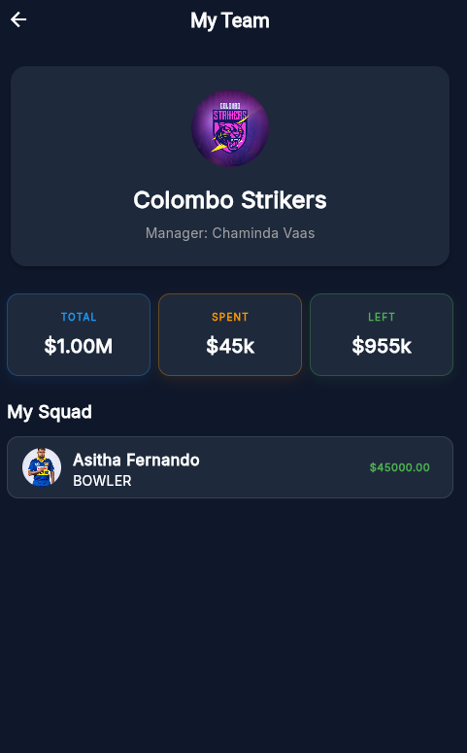
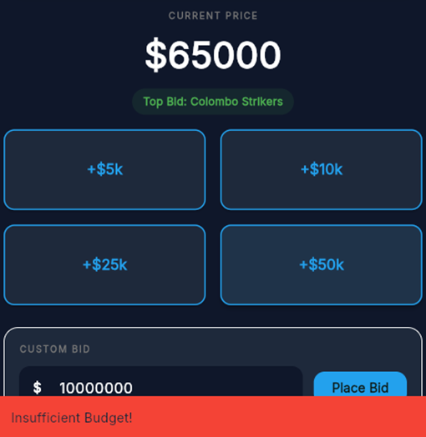
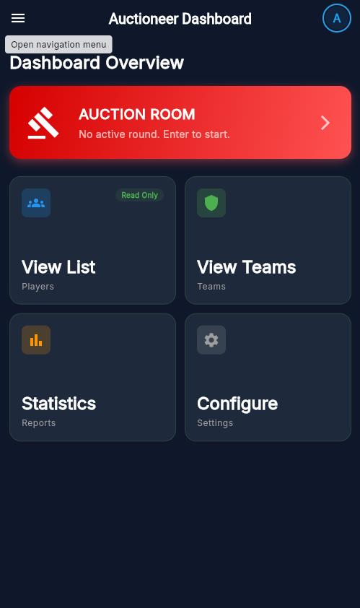
7. Auctioneer Functions
7.1 Starting an Auction
- Log in as Auctioneer.
- Select a player for auction.
- Click Start Auction.
- Bidding becomes active for all team managers.
7.2 Monitoring Bids
- Auctioneer can view:
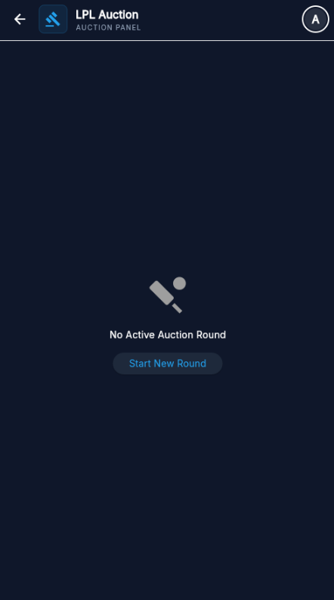
  - Current highest bid
  - Bidding team
  - Real-time bid updates
7.3 Stopping the Auction
- Click Stop Auction.
- The system:
  - Assigns the player to the highest bidding team
  - Updates team budget
  - Stores auction results

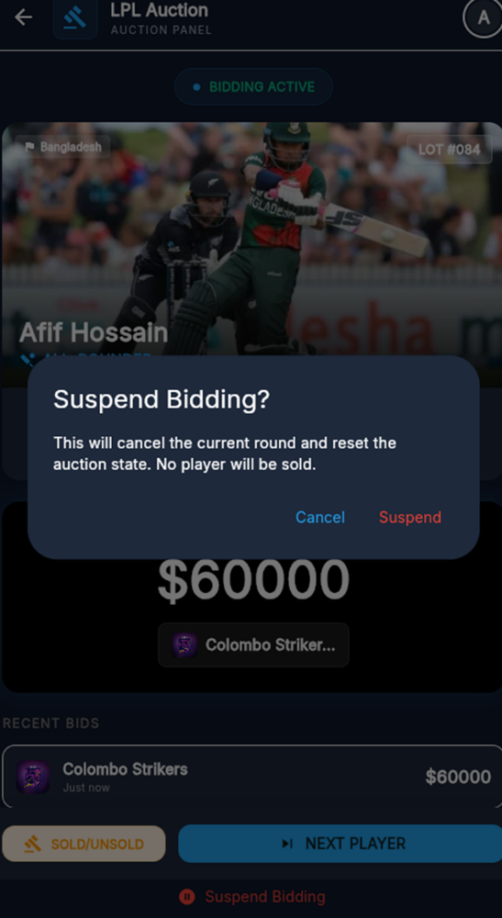
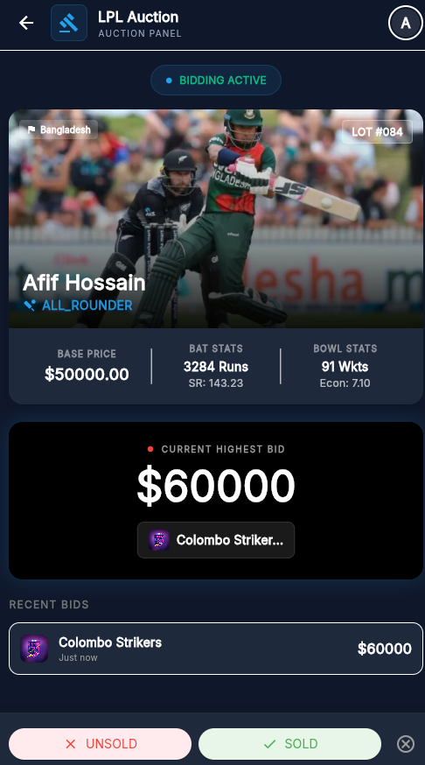
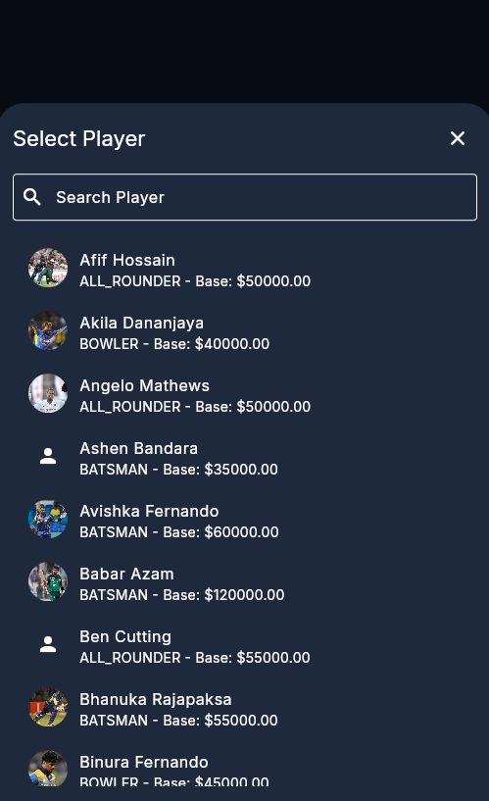
8. Budget Management
- Each team is assigned a fixed budget.
- The system automatically:
  - Deducts bid value from remaining budget
  - Prevents overspending
- Budget updates occur instantly after each successful bid.
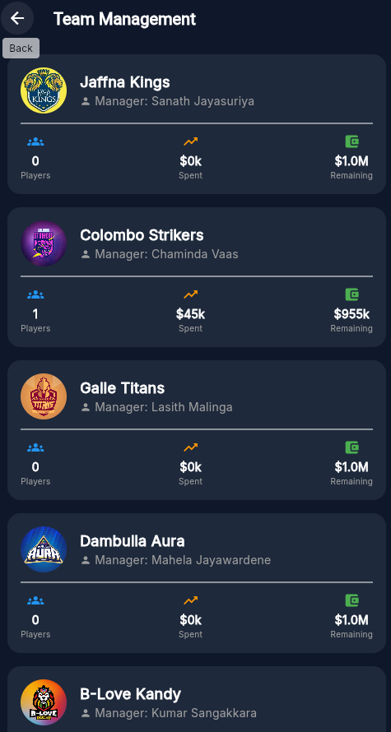
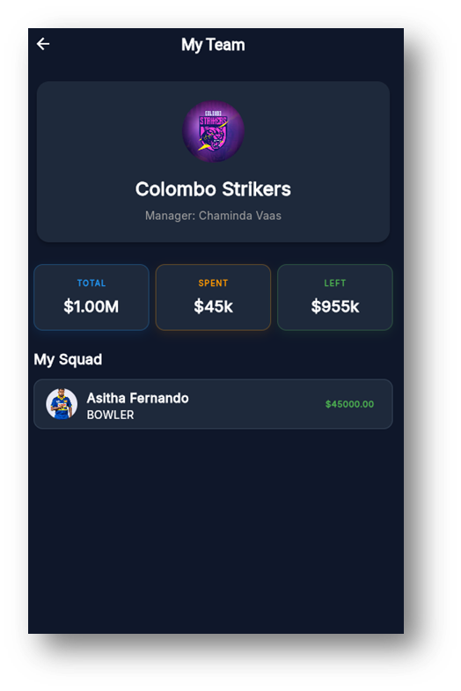
9. Auction Results and Data Storage
After an auction round:
- Player is assigned to the winning team
- Bid details are stored in the database
- Auction history is available for reporting and auditing
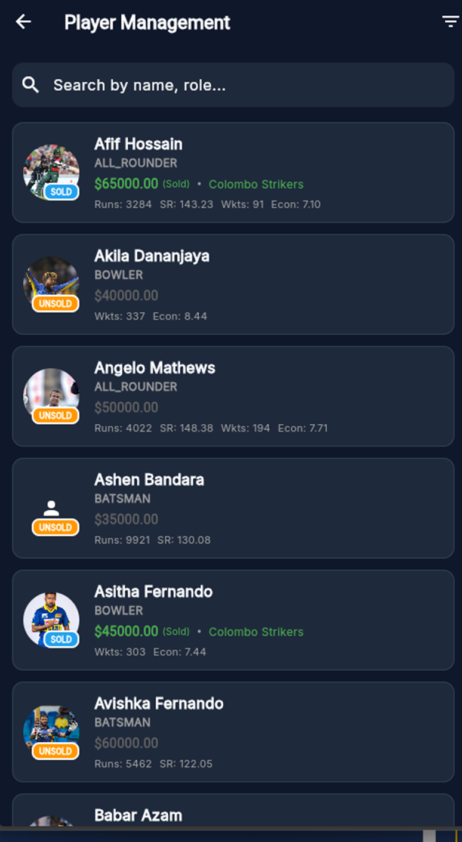
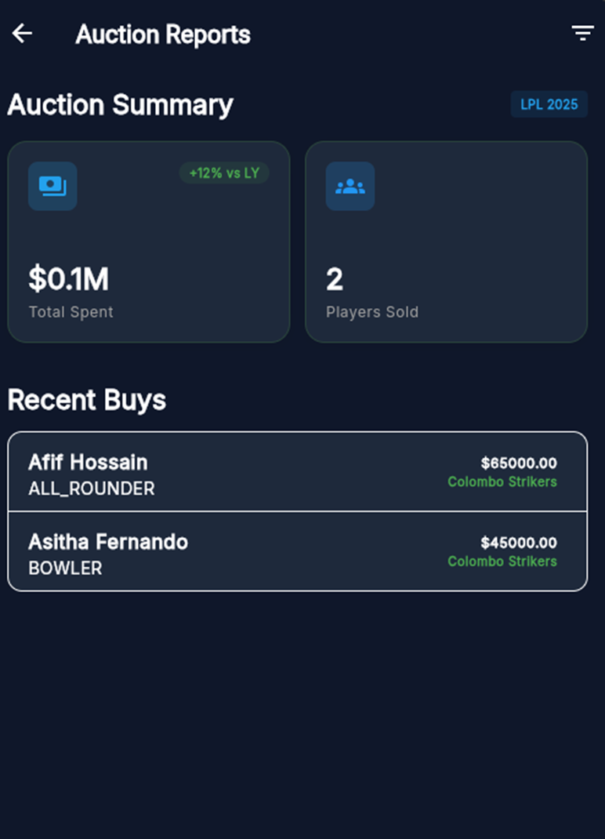
10. Logout Procedure
- Click Logout from the dashboard.
- User session is terminated.
- User is redirected to the login screen.
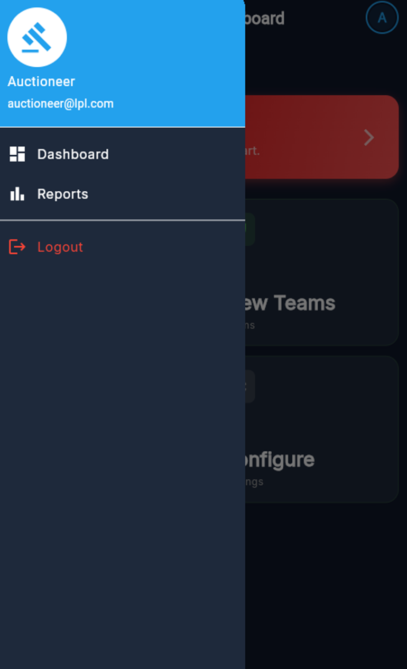
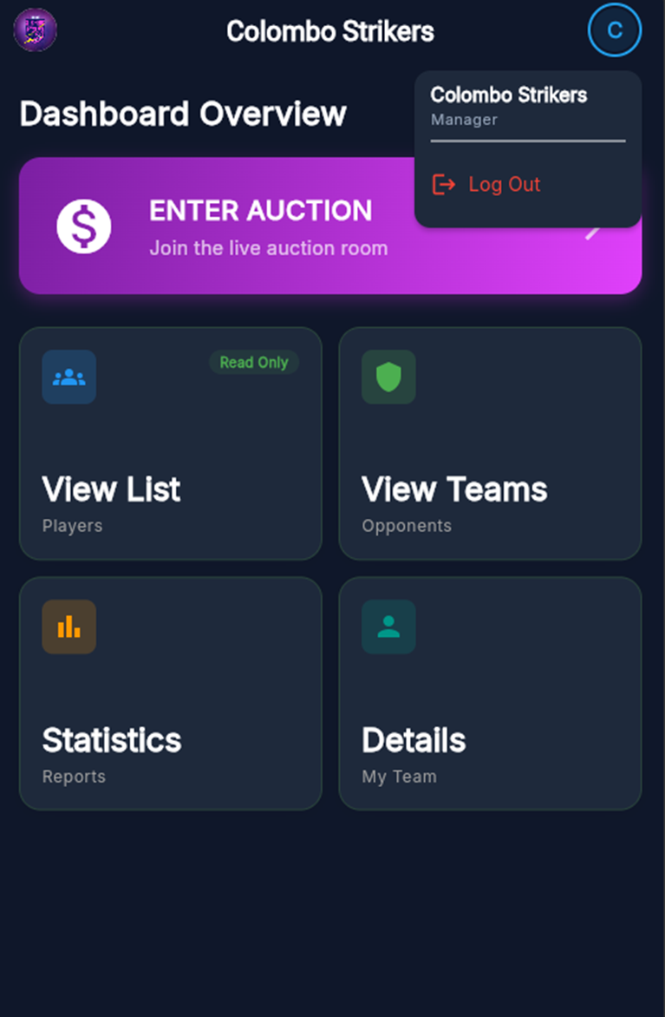
11. Error Messages and Troubleshooting
Issue | Possible Cause | Solution
Login failed | Incorrect credentials | Verify email and password
Bid rejected | Budget exceeded | Check remaining budget
No real-time updates | Server not running | Restart backend server
App not loading | Network issue | Check internet connection
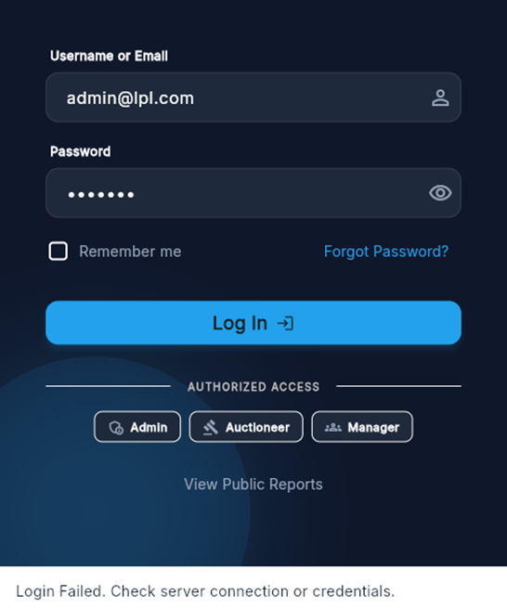
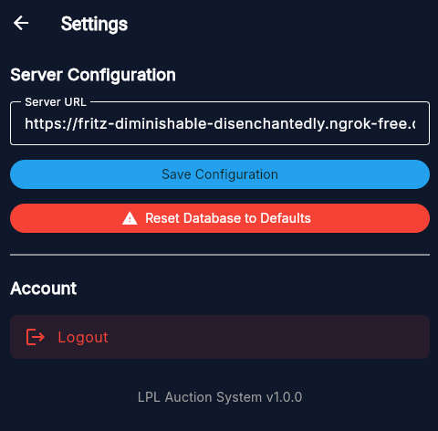
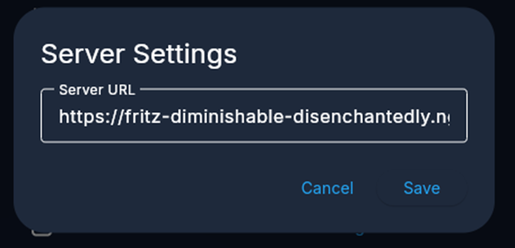
12. Security Features
- Role-based access control
- Secure authentication
- Session handling
- Server-side bid validation
These features ensure system integrity and fair auction operations.

13. Conclusion
This user manual outlines the complete operational flow of the Cricket Players Auctioning System. By following the provided steps, users can efficiently conduct player auctions with improved accuracy, transparency, and speed compared to traditional manual processes. The system is user-friendly and designed to support real-time decision-making during auction events.
